Effective Visible Light-Activated N/Sn-TiO₂/In₂O₃ with Enhanced Photocatalytic Activity

With the purpose of improving the utilization efficiency of the solar energy in the photocatalytic degradation of organic compounds, the visible-light activated TiO₂ materials have been the research focuses during the past few years. Great attempts have been made to develop TiO₂-based photocatalysts sensitive to visible light, such as surface sensitization, metal or nonmetal ions doping, combing with other semiconductor and so on.¹ Among these strategies, impurity doping is of particular interest since the preparing process is simple and controllable, more importantly, the dopant plays an important effect on the crystal structure, energy band structure and photo responsive properties of TiO₂.^{1c-g} However, merely inducing visible light absorption does not always result in the high-efficiency visible light photocatalytic activity^{1f, g} because another key to enhancing the photocatalytic activity, effective separation of photo electrons and holes, is indispensable. Therefore, it is still a desirable issue to design and fabricate a novel TiO₂- based photocatalyst with highly active under visible light irradiation,
Herein we report a novel TiO₂ system which tri-doped with nitrogen, tin and indium. Our findings demonstrated that incorporation of nitrogen and tin could enhance the absorption of TiO₂ in the visible light region and that modification of indium sesquioxide on the TiO₂ surface could accelerate the separation of photogenerated carries. Accordingly, the present tri-doped TiO₂ showed the remarkably improvement of photocatalytic activity under visible light irradiation compared to the nitrogen doped TiO₂, which is a typical visible photocatalyst. To the best of our knowledge, this is the first example to show the synergistic effect of nitrogen, tin and indium tri-doping on the visible-light photocatalytic activity of nano TiO₂.
The nitrogen, tin and indium tri-doped TiO₂ (N/Sn-TiO₂/In₂O₃) was prepared by a simple method of hydrolysis-precipitation synthesis and then calcined in air. As reference for comparison, pure TiO₂, nitrogen doped TiO₂ (N-TiO₂), tin codoped TiO₂ (Sn-TiO₂) and indium doped TiO₂ (In-TiO₂) were also prepared (described in the Supporting Information). The photocatalytic activities of these photocatalysts were evaluated by monitoring the degradation of 4-chlorophenol (4-CP) upon irradiation with UV and visible light (>400 nm) according to a procedure reported in the literature.² Each photocatalytic experiment was repeated three times and the reproducibility of the results was found to be within acceptable limits (±5%). Figure 1 shows the variation of 4-chlorophonel concentration as a function of photodegradation time under UV (Figure 1A) and visible light irradiation (Figure 1B). The ln(C₀/C) values of 4-chlorophenol show a linear correlation with photodegradation time, suggesting a first-order reaction for all samples. The experimental results of the photodegradation under UV and visible light are illustrated in Table S1. It was found that all the samples exhibit high photocatalytic activity under UV irradiation and N/Sn-TiO₂/In₂O₃ shows an accelerating degradation rate than those of pure TiO₂, N-TiO₂, Sn-TiO₂ and In-TiO₂. In case of visible light irradiation, only a very limited visible light photocatalytic activity is achieved for N-TiO₂, Sn-TiO₂ and In-TiO₂. In contrast, about 90% of the 4-chlorophenol was decomposed in N/Sn-TiO₂/In₂O₃ system after illumination for 8 h, which is about four times than that of N-TiO₂. These results unambiguously suggest that a significantly improved photocatalytic activity is realized by tri-doping with three dopants, nitrogen and tin and indium.
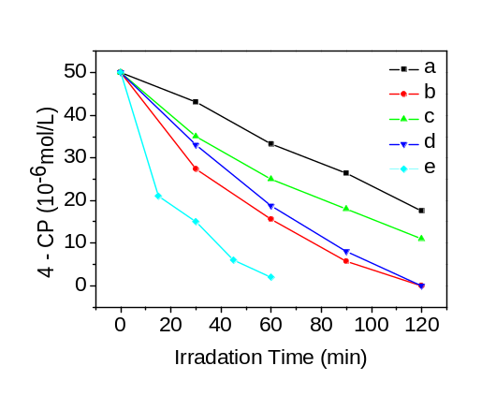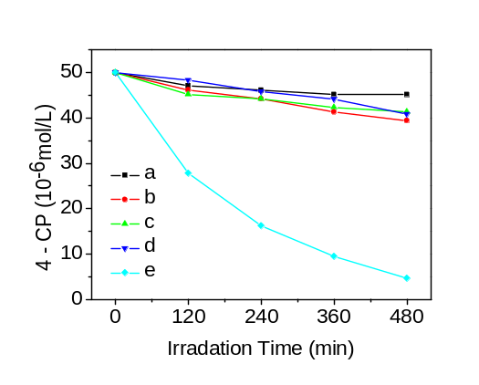
Figure 1. Temporal course of the photodegradation of 4-CP (5.0×10⁻⁶ M; 40 mL) in aqueous dispersions containing 5 mg of catalystsand under UV irradiation (left) and 10 mg under visible light (right) irradiation: (a) pure TiO₂, (b) N -TiO₂, (c) Sn-TiO₂, (d) In-TiO₂ and (e) N/Sn-TiO₂/In₂O₃.
The crystalline phase, cell parameters, cell volume, mean crystallite sizes and BET surface areas of these catalysts are given in the Supporting Information. Only anatase was observed in all TiO₂ samples. There was no obvious difference of crystallite sizes and surface areas between pure TiO₂ and N-TiO₂. However, Sn-TiO₂, In-TiO₂ and N/Sn-TiO₂/In₂O₃ show smaller crystallite sizes and enhanced surface areas compare to the pure TiO₂. Figure 2 gives the corresponding UV-vis diffuse reflectance spectra of pure TiO₂ and doped TiO₂. In comparison to the pure TiO₂, N-TiO₂ shows a typical absorption in the visible region.² The response of Sn-TiO₂ in 400-500 nm can be clearly observed,
which is fairly consistence with our previous work.³ In-TiO₂ also exhibited a slight absorption in the visible light region. It is very interesting that this visible light absorption remarkably increased after tridoping with nitrogen, tin and indium. It is apparent that
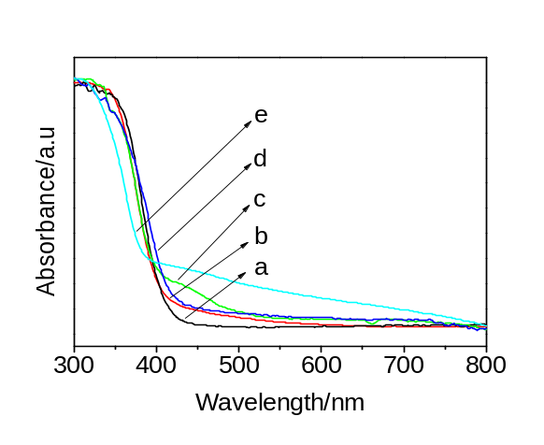
Figure 2. Diffuse reflectance absorption spectra of (a) pure TiO₂, (b) N -TiO₂, (c) Sn-TiO₂, (d) In-TiO₂ and (e) N/Sn-TiO₂/In₂O₃.
Nitrogen, tin and indium tridoping can result in a substantial visible-light response of TiO₂ photocatalysts. Except these visible absorptions, the absorption edges of N/Sn-TiO₂/In₂O₃ exhibit a blue-shift compare to pure TiO₂, which is attributed to the decrease in crystallite sizes.
The question now arose: why nitrogen and tin doping could enhance the visible-light absorption and why additional doping with indium could improve the photocatalytic activity. Therefore the N/Sn-TiO₂/In₂O₃ sample was investigated by X-ray photoelectron spectroscopy (XPS) technique to determine the oxidation state of the dopants in it. Figure 3a shows the N 1s peak of N/Sn-TiO₂/In₂O₃ in which a broad peak centered at about 400.9 eV extending from 396 to 405 eV is observed. It is well known that the origin of the broad peak in the 396-405-eV region is still in controversy due to using different nitrogen sources and sample-preparation conditions.⁴ Considering the preparation of wet
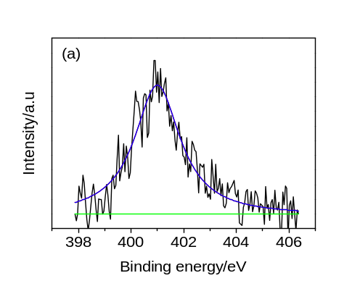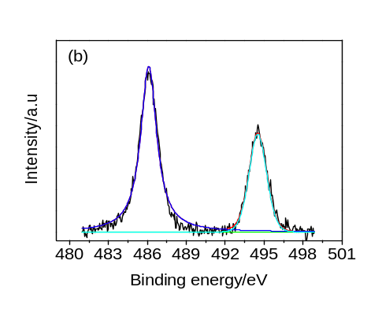
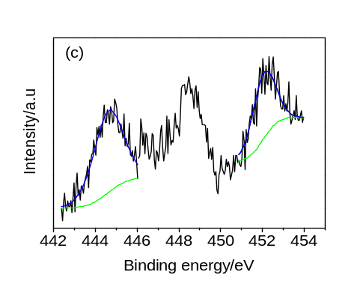
Figure 3 XPS spectra of N 1s(a), Sn 3d(b) and In 3d(c) Ti 2p(d) for N/Sn-TiO₂/In₂O₃.
chemical method, the BE 400.9 eV was assigned to an oxidation of nitrogen similar to NO, indicating a possible Ti-N-O linkage on the surface of N-TiO₂ nanoparticles.^{4c, d} These NO species play an important role of impurity sensitization, and accordingly are responsible for the absorption in the visible-light region, although only the very limited visible-light photocatalytic activity can be achieved for N solo-doped TiO₂. As shown in Figure 3b, the peaks around 486.1 eV and 494.5 eV are assigned to Sn 3d_{5/2} and Sn 3d_{3/2} respectively. We attribute these peaks to the doping Sn ions substituting lattice Ti in the N/Sn-TiO₂/In₂O₃ sample since the 3d_{5/2} position is located between those of Sn 3d_{5/2} in SnO₂ (486.7 eV) and Sn 3d_{5/2} in metallic Sn (485.0 eV).^{3, 5} Our previous work proposed that the doping energy level of Sn⁴⁺ ions is located 0.4 eV below the conduction band which allows the response of TiO₂ to the visible light.³ Thus the intensity of absorption in the visible-light region is increasing for N/Sn-TiO₂ compared to N -TiO₂. In case of In 3d region (Figure 3c), the peaks around 444.6 eV and 452.2 eV are consistente with In 3d_{5/2} and In 3d_{3/2} in In₂O₃, respectively.⁶ This reveals that the indium dopant exist on the surface of catalyst by forming the In₂O₃. The additional peak around 448.5 eV is ascribed to the satellite peak of Ti 2p.⁷ The XPS spectra of Ti 2p region and O 1s region were also carried out (see Figure S3 in Supporting Information). The Ti 2p_{3/2} peak at 459.5 eV indicates that Ti exhibited an oxidation state of 4+ in an octahedral environment of TiO₂. This value is higher than that of pure TiO₂ (458.6 eV), which can be interpreted by the Sn dopants in the TiO₂ matrix. In the N/Sn-TiO₂/In₂O₃ sample, the electrons would transfer from Ti to Sn through their oxygen bridge in the linkage structure (Ti-O-Sn), and thus the binding energy of Ti decreased due to the higher electronegativity of Sn compared to Ti.⁸ The O 1s region is composed of two peaks at 529.5 and 531.8 eV, corresponding to the Ti-O bond in TiO₂ and hydroxyl groups on the surface.⁹
Based on the above experiment data, the high photocatalytic activity of N/Sn-TiO₂/In₂O₃ system can be explained. The NO species on the surface of catalyst introduced by N doping would form the surface state energy level and extend the spectral absorption to the visible-light region. This visible-light response can further enhanced by the incorporation of Sn in the TiO₂ lattice. As reported by many researchers, composite semiconductors can inhibit the recombination of photogenerated electrons and holes, and thus increase the lifetime of photoinduced carries and improve the quantum yield.¹⁰ In our case, In₂O₃ formed on the surface would favor the transfer of electrons and holes through the following way: under the light irradiation, the conduction band electrons in TiO₂ would migrate to the lower lying In₂O₃ conduction band, whereas the holes in valance band of In₂O₃ would migrate to that of TiO₂. This was suggested by the previous study on the TiO₂-In₂O₃ composite films and confirmed by our recent work.^{7, 10d} The synergistic effects of creating visible-light absorption and then accelerating the separation of photoinduced carriers are responsible for the high photocatalytic activity for this N/Sn-TiO₂/In₂O₃.
In summary, the present work is the first to use a simple strategy to obtain visible-light-driven N/Sn/In tri-doped titania (N/Sn-TiO₂/In₂O₃) with a significantly improved photocatalytic activity. We propose that the enhanced visible-light absorption attributed to the N and Sn doping and the promoting separation of charge carriers attributed to the composite In₂O₃ on the surface are the main factors leading to the improved photocatalytic activity. The doping ration of N, Sn and In presented here is far from being optimized but this study indicates that multiple doping is an effective route to design and fabricate the highly active visible-light TiO₂-based photocatalysts. It is of great interest to investigate the synergetic effects of other multiple dopants on the optical response, crystallinity, surface areas, and photocatalytic activity of TiO₂.

Acknowledgment. This work was supported by National Natural Science Foundation of China (No. 50872056).
Supporting Information Available: Experimental details for catalyst preparation, characterization and evaluation of photocatalytic activity, XRD, BET surface area, Raman and XPS spectra of Ti 2p and O1s. This material is available free of charge via the Internet at http://pubs.acs.org.

References
1 (a) Zhang, M.; Chen, C. C.; Ma, W. H.; Zhao, J. C. Angew. Chem. Int. Ed. 2008, 47, 9730–9733. (b) Cao, Y. A.; Zhang, X. T.; Yang, W. S.; Du, H.; Bai, Y. B.; Li, T. J.; Yao, J. N. Chem. Mater. 2000, 12, 3445–3448. (c) Asahi, R.; Morikawa, T.; Ohwaki, T.; Aoki, K.; Taga, Y. Science 2001, 293, 269–271. (d) Choi, W.; Termin, A.; Hoffmann, M. R. J. Phys. Chem. 1994, 98, 13669–13679. (e) Nagaveni, K.; Hegde, M. S.; Madras, G. J. Phys. Chem. B 2004, 108, 20204–20212. (f) In, S.; Orlov, A.; Berg, R.; García, F.; Jimenez, S. P.; Tikhov, M. S.; Wright, D. S.; Lambert, R. M. J. Am. Chem. Soc. 2007, 129, 13790–13791. (g) Liu, G.; Zhao, Y. N.; Sun, C. H.; Li, F.; Lu, G. Q.; Cheng, H. M. Angew.Chem.Int.Ed. 2008, 47, 4516–4520.
2 Gao, B. F.; Ma, Y.; Cao, Y. A.; Yang, W. S.; Yao, J. N. J. Phys. Chem. B 2006, 110, 14391–14397.
3 Cao, Y. A.; Yang, W. S.; Zhang, W. F.; Liu, G. Z.; Yue, P. New. J. Chem. 2004, 28, 218– 222.
4 (a) Fujishima, A.; Zhang, X. T.; Tryk, D. A. Surface Science Reports 2008, 63, 515–582. (b) Chen, X. B.; Burda, C. J. Phys. Chem. B 2004, 108, 15446–15449. (c) Gopinath, C. S. J. Phys. Chem. B 2006, 110, 7079–7080. (d) Sato, S.; Nakamura, R.; Abe, S. Applied Catalysis A 2005, 284, 131–137. (e) Sakthivel, S.; Janczarek, M.; Kisch, H. J. Phys. Chem. B 2004, 108, 19384–19387.
5 (a) Ahn, H. J.; Choi, H. C.; Park, K. W.; Kim, S. B.; Sung. Y. E. J. Phys. Chem. B 2004, 108, 9815-9820. (b) Hegde R. I. Surf. Interface Anal. 1982, 205, 4.
6 Reddya, B. M.; Chowdhury, B.; Smirniotis, P. G. Applied Catalysis A 2001, 219, 53–60.
7 Long, H. J.; Wang, E. J.; Dong, J. Z.; Wang, L. L.; Cao, Y. Q.; Yang, W. S.; Cao, Y. A. ACTA CHIMICA SINICA 2009, 67, 1533–1538.
8 Li, J.; Zeng, H. C. J. Am. Chem. Soc. 2007, 129, 15839–15847.
9 Zhao, W.; Ma, W. H.; Chen, C. C.; Zhao, J. C.; Shuai, Z. G. J. Am. Chem. Soc. 2004, 126, 4782–4783.
10 (a) Chen, D.; Zhang, H.; Hu, S.; Li, J. H. J. Phys. Chem. C 2008, 112, 117–122. (b) Neppolian, B.; Wang, Q. L.; Yamashita, H.; Choi, H. Applied Catalysis A 2007, 333, 264–271. (c) Yu, H. T.; Quan, X.; Chen, S.; Zhao, H. M.; J. Phys. Chem. C 2007, 111, 12987–12991. (d) Poznyak, S. K.; Talapin, D. V.; Kulak, A. I. J. Phys. Chem. B 2001, 105, 4816–4823.

